**DEVOPS BOOTCAMP ASSIGNMENT USING GCP ACCOUNT**

**Ashutosh Gupta – 1209814**

1. **Creating local GIT repository as developerA**

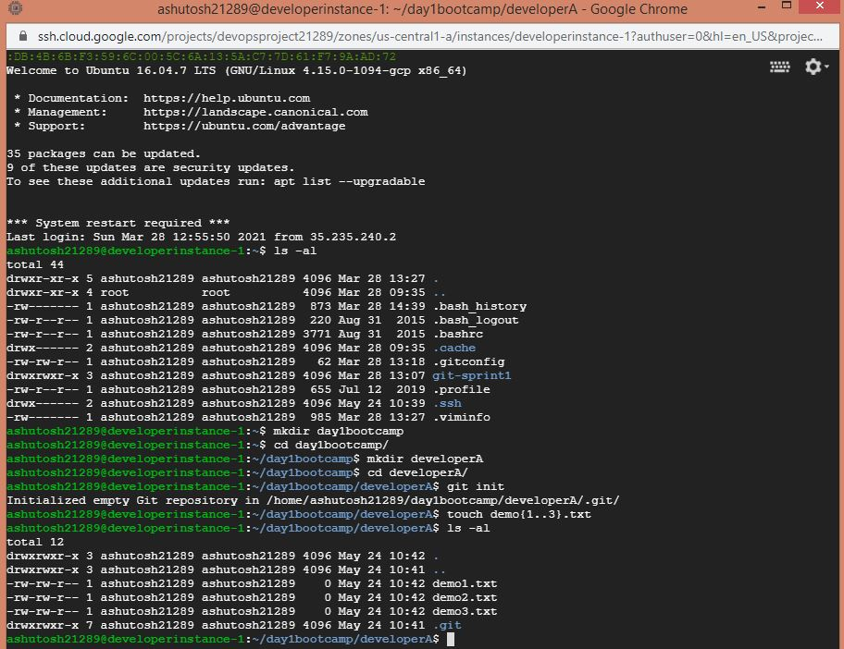

1. **Adding 3 files**

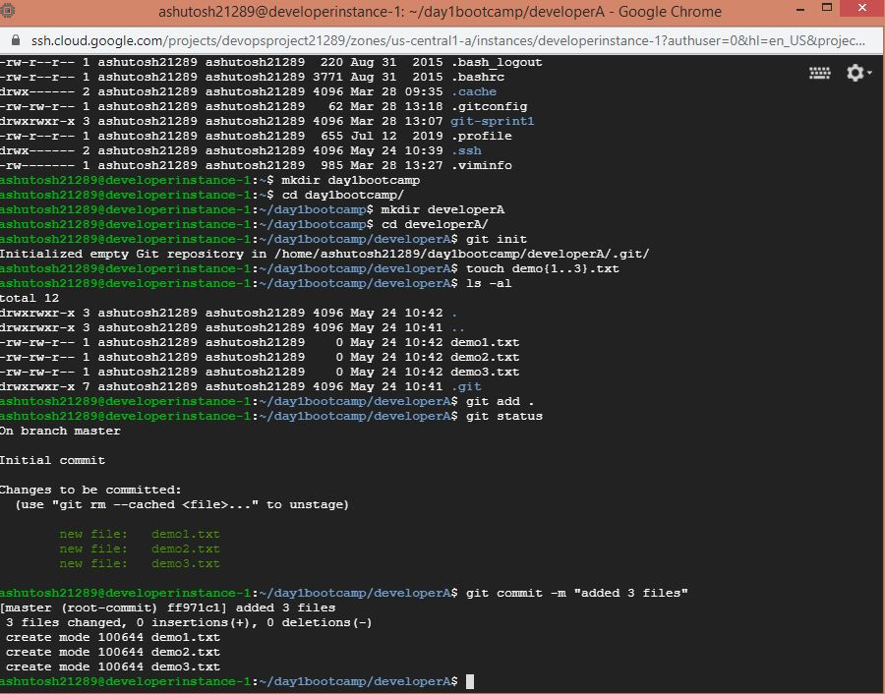

1. **Creating Remote Git Hub Repository**

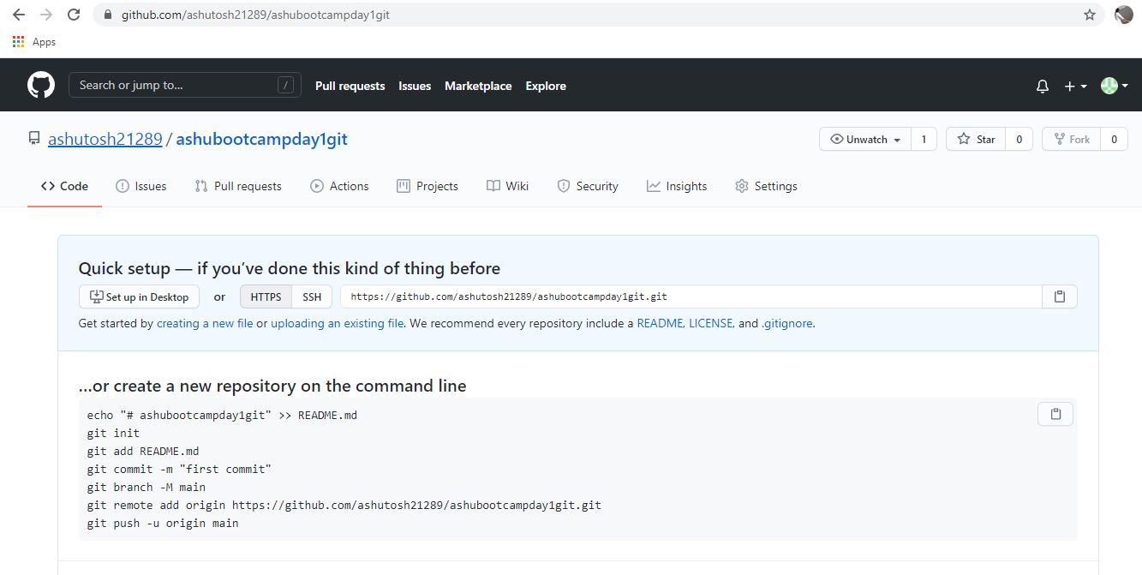

1. **Adding remote to local repository**

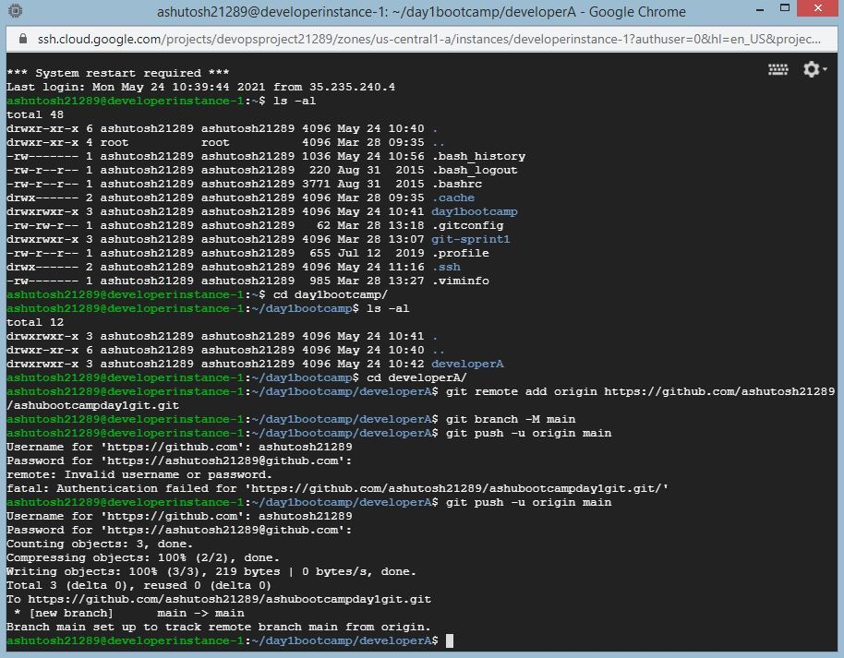

1. **Clone remote repository**

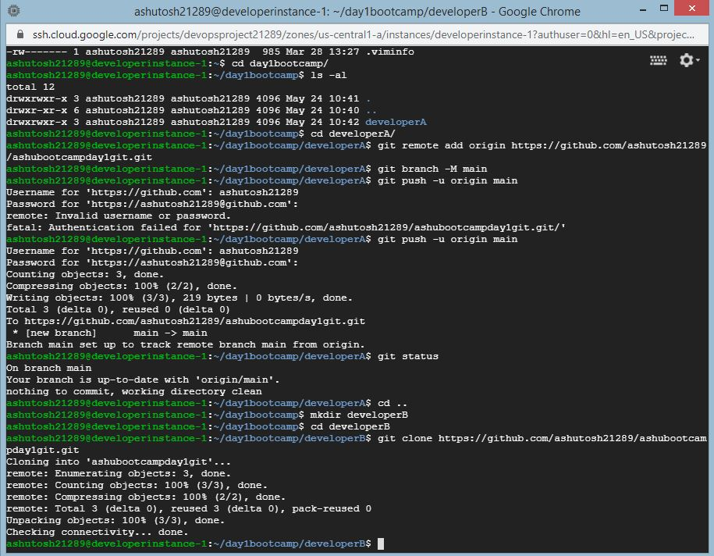

1. **Make and commit changes via developer B**

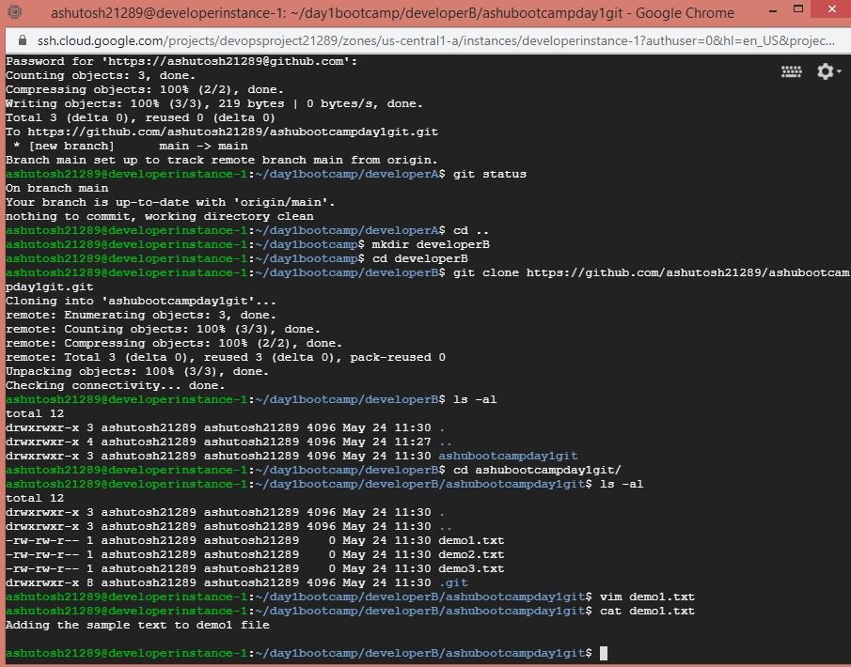

1. **Synchronize A and B**

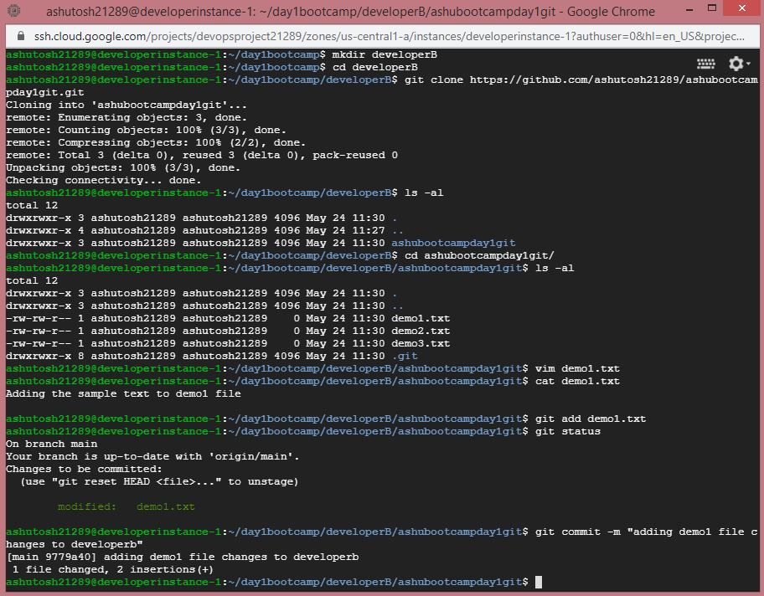

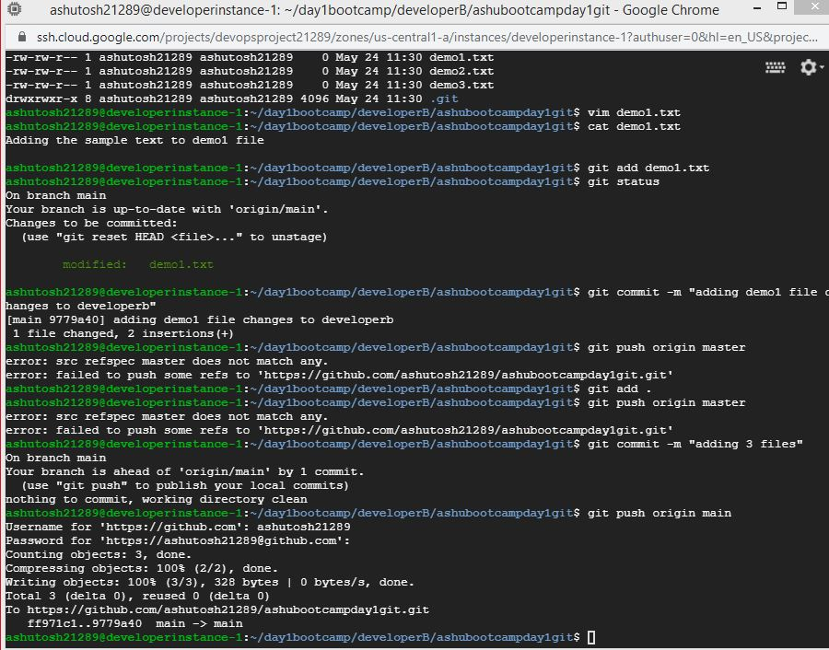

1. **Changes reflected to GitHub**

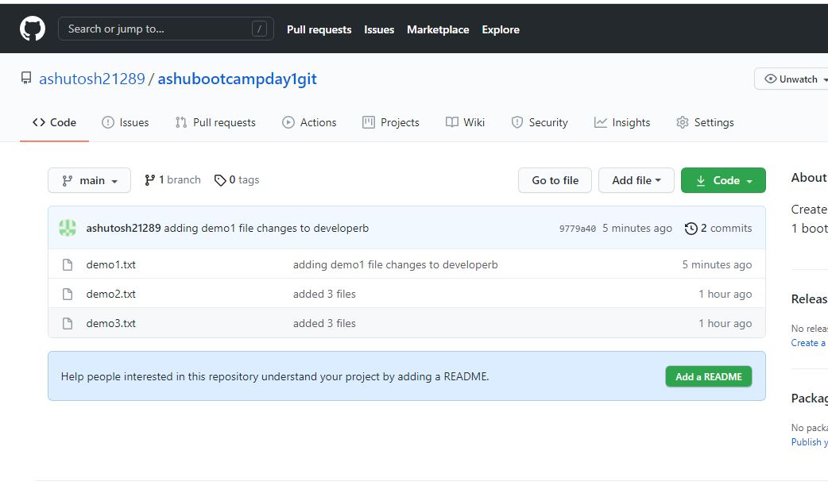

1. **Creating feature1 branch and merge the changes**

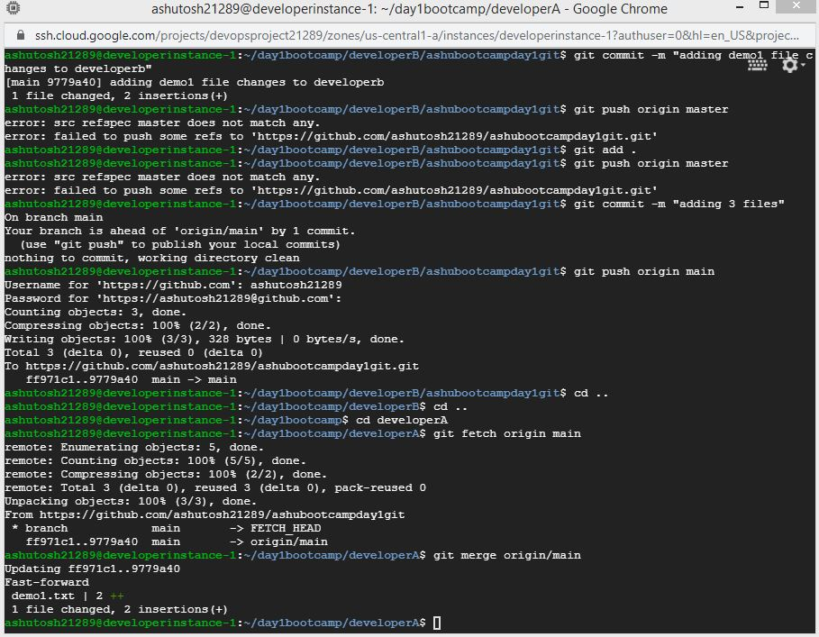

1. **Finally deleting feature1 branch**

